The following is to ensure school-level parent and family engagement plans meet the requirements of Section 1116(b) of the Elementary and Secondary Education Act (ESEA), as amended by the Every Student Succeeds Act (ESSA).
Assurances
The above named school agrees to the following assurances:
- Involve parents of children served in Title I, Part A in decisions about how Title I Part A funds are spent;
- Carry out the programs, activities, and procedures in accordance with the definitions in Section 8101 of ESEA;
- Jointly develop/revise plan with parents and make available to the local community;
- Involve parents and families in planning, reviewing, and improving schoolwide program plan;
- Use the findings of the parent and family engagement plan review to design strategies for more effective engagement, and to review, if necessary, the school’s parent and family engagement plan;
- Provide each family with timely notice information regarding their right to request information on the professional qualifications of the student’s classroom teachers and paraprofessionals;
- Notify each family, in a timely manner, when their child has been assigned, or has been taught for four or more consecutive weeks, by a teacher(s) who is out of field;
- Provide each family with an individualized student report about the performance of their child(ren) on the State assessments [ESEA Section 1116]
Mission Statement
1. Does the mission statement include:  How the parent and family engagement plan is a shared responsibility?  How the parent and family engagement plan will assist in providing high quality instruction for all learners? | The mission at Lockhart Middle School is to lead our students to success with the support and engagement of families and the community. Lockhart Middle School encourages all parents to be in involved in all aspects of its programs. Shared responsibility is essential in our students’ education. We will work in conjunction with parents and families to plan for and provide meaningful activities and events that support instruction needed for the various learners within Lockhart Middle School. Activities and Events include but are not limited to hosting curriculum nights that are aligned to grade level standards to provide strategies for parents when working with students at home.

Involvement of Parents
2. Does the plan include:  How the school will involve the parents and families in an organized, ongoing, and timely manner in the planning, review and improvement of Title I programs, including involvement in decision making of how funds for Title I will be used [ESEA Section 1116]? | Lockhart Middle School is committed to organized, ongoing, and timely manner of involving parents through the following methods:  - Home-to-school- and school-to-home communication in English and or other languages  - Flyers  - Newsletters  - Email  - And other known best practices  Lockhart Middle School involves parents and families in the planning, review and improvement of Title I programs, including involvement in the decision making of how funds for Title I will be through School Advisory Council (SAC) meetings and Title I Annual Meeting.

Coordination and Integration with Other Federal Programs
3. Does the plan include:  How the school will coordinate and integrate parent and family engagement programs and activities?  How the school will coordinate and integrate parent and family activities that teach parents how to help their child(ren) at home [ESEA Section 1116]? | Lockhart Middle School will coordinate and integrate parent and family engagement by providing activities and events throughout the school year. Activities and events will support, encourage and provide parents with research based best practices for working with their students’ at home.
Program | Coordination
Pre-K Varying  Exceptionalities ESE - IDEA | Not Applicable to Lockhart Middle School
Title I | Administrators and Title I Contact will coordinate with the Title 1 office to provide opportunities for parent and family engagement in students’ various learning environments (school and home)
Title II | Professional Development modules will be provided throughout the school year to address parent and family engagement with teachers and staff
Title III | The Curriculum Compliance Teacher (CCT) ensures that our English Language Learners (ELLs) are having their educational needs met
Title X | District Social Worker, Guidance Counselors and Support Staff provides resources to those students identified as homeless under the McKinney-Vento Act

Annual Parent Meeting
4. Does the plan include:  A description of the specific steps the school will take to conduct the annual meeting to inform parents and families of participating children about the school’s  Title I program?  A description of the nature of the Title I Program that is shared with parents (schoolwide or targeted assistance)?  A description of how the meeting will cover adequate yearly progress (AYP), school choice, and the rights of parents are covered at the annual meeting? | Lockhart Middle School will host an annual Title I meeting to inform parents and families of children participating in Title 1 program at the beginning of the school year, during Open House. The annual meeting will educate parents via use of PowerPoint Presentation and handouts.  The description of the nature of the Title I Program shared with parents is as follows:  Title I, Part A, provides local educational agencies (LEA) resources that help children gain a high-quality education and the skills to master the Florida Standards. Title I provides additional resources to schools with economically disadvantaged students. These resources provide additional teachers, professional development, extra time for teaching, parent involvement activities, and other activities designed to raise student achievement. Two models are used in Title I schools to provide these services. Schoolwide reform models provide all students with access to services. Targeted assistance models provide services to select students in Title I schools.  For more information please visit the Florida Department of Education, Office of Title I Programs and Academic Intervention Services at http://www.fldoe.org/bsa/title1/title_compile.asp or our district’s Title I website at http://www.ocps.net/departments/titlei  Below are the specific steps that Lockhart Middle will take to conduct the Title I Annual Meeting.
Activity/ Task | Person Responsible | Timeline | Evidence of Effectiveness
Notices sent home to parents | School Administrators | September 11, 2017 | Copy of notice with date of dissemination
Agenda and presentation materials developed | School Administrators | September 13, 2017 | Copies of agenda
Develop Sign in Sheets | School Administrators/Title I Coordinator | September 25, 2017 | Copies of sign in sheets
Conduct Title I Annual Meeting | School Administrators | September 25, 2017 | Copies of Agendas
Maintain Documents | Title I Coordinator | September 25, 2017 | Copies of all Documents

Flexible Parent Meetings
5. Does the plan include:  How will the school offer a flexible number of meetings, such as meeting in the morning or evening?  How will the school provide, with Title I funds, transportation, child care or home visits, as such services relate to parent and family engagement [ESEA Section 1116]? | Lockhart Middle School will offer a flexible number of meetings. There will be morning and afternoon meetings as well as evening opportunities for activities and events. Children will be welcome to attend before school and after school events if the parent is unable to find arrangements for the child. Teacher volunteers will be available for child care services if needed.

Building Capacity
6. Does the plan include:  How the school will implement activities that will build the capacity for meaningful parent/family engagement?  How will the school implement activities that will build relationships with the community to improve student achievement?  How the school will provide material and training to assist parents/families to work with their child(ren)?  How the school will provide other reasonable support for parent/family engagement activities [ESEA Section 1116]? | Lockhart Middle is committed to building capacity of all key stakeholders who play a vital role in our student’ academic success. We provide workshops and activities that strength these relationships throughout the year. Community members and organizations can volunteer to support through our Partners In Education (PIE) coordinators as well as our ADDitions coordinators.  Below are the specific steps that Lockhart Middle will take to build capacity for meaningful parent and family engagement.
Activity/ Task | Person Responsible | Correlation to Student Achievement | Timeline | Evidence of Effectiveness
Meet the Teacher | Instructional Staff | Teachers will introduce classroom expectations, routines and establish rapport | August 2017 | Sign In Sheets
SAC/PTSA | Administration, Parents, Techers and Community Members | Parents and community members can give input to situations that will impact their student’s education | September 2017- May 2018 | Sign in Sheets, Agendas
Parent Conferences | Administration, Parents, Teachers, Students and Community Members | Affords parents the opportunity to discuss their students’ academic progress | September 2017- May 2018 or As Needed | Meeting Calendar or Notes
Open House | Administration and Teachers | Affords parents the chance to meet their child’s teacher and become familiar with Lockhart procedures | September 2017 | Sign in Sheets. Agendas
Coffee with Counselors | Guidance Counselors | It gives parents the opportunity to learn and discuss various activities and or opportunities with their students’ grade level guidance counselor | October 2017  December 207  April 2018 | PowerPoints  Agendas  Sign in Sheets
Community Teach In | Authorized School Personnel, PIE Coordinator and Administration | This event introduces students to different careers in our community | November 2017 | Sign in Sheets, Agendas
Literacy Night | Administration, Teachers, and Media Specialist | This event allows for hands on activities that students and parents can do together to practice and improve their reading skills | November 2017 | Sign in Sheets Agendas
Math Night | Administration  Teachers | This event allows for hands on activities that students and parents can do together to practice and improve their math skills as well as showcase student work. | November 2017 | Sign in Sheets Agendas
Center for the Advancement of Science and Engineering (CASE) Open House | CASE Teachers  CASE Coordinator  Administration | This event affords parents an indepth picture of the skills students are learning through the CASE Program. It will showcase student work. | January 2018 | Sign in Sheets Agendas
Civics Night | Administration  Teachers | This event allows for hands on activities that students and parents can do together to deepen knowledge of standards covered in Civics. | February 2018 | Sign in Sheets Agendas

Staff Development
7. Does the plan include:  A description of the professional development activities the school will provide to educate the teachers, specialized instructional support personnel, principals, other school leaders and other staff:  - with the assistance of parents/families, in the value and utility of contributions of parents/families?  - in how to reach out to, communicate with, and work with parents/families as equal partners?  - in implementing and coordinating parent/family programs, and in building ties between parents/families and the school [ESEA Section 1116]? | Lockhart Middle is dedicated to building capacity of all school staff. Throughout the year, various professional development activities are provided for continuous learning of instructional, specialized support personnel, other school leaders (coaches, testing coordinators, etc.) and staff to build capacity in parent and family engagement.  Below are the specific activities and tasks that Lockhart Middle will implement to build capacity for meaningful parent and family engagement.
Activity/ Task | Person Responsible | Correlation to Student Achievement | Timeline | Evidence of Effectiveness
Parent and Family Engagement Professional Development Module 1 - Building Strong Partnerships with Parents and Families | School Administration  Title I Coordinator | Improved school staff resources to create a welcoming school environment, understand and value the importance of parent and family engagement, and maintain strong school to home partnerships | October  2017 – November 3, 2017 | Sign-in sheets, exit slips
Parent and Family Engagement Professional Development Module 2:  Building Ties  Between Home and  School | School Administration  Title I Coordinator | Improved ability of staff to work with parents and families | November 2017-Feburary 5, 2018 | Sign-in sheets, exit slips
Parent and Family Engagement Professional Development Module 3:  Implementation and  Coordination of  Parent and Family Engagement  Programs | School Administration  Title I Coordinator | Increased parent and family participation in school activities which support student achievement | January 2018-March 30, 2018 | Sign-in sheets, exit slips
Parent and Family Engagement Professional Development Module 4:  Communicating  and Working with  Parents as Equal Partners | School Administration  Title I Coordinator | Improved relationship, communication and collaboration between  parents and school | March 2018 – May18, 2018 | Sign-in sheets, exit  slips

Other Activities
8. Does the plan include:  How other activities, such as the parent resource center, the school will conduct to encourage and support parents and families in more meaningful engagement in the education of their child(ren) [ESEA Section 1116]? | Lockhart Middle will use other avenues as well to encourage and support parents in more fully participating in the education of their child.  The media center offers computer access to allow students and parent’s to access district applications and other materials during extended Media Hours on Tuesdays and Thursdays.  There are also District Parent Academy and Virtual Academy events offered throughout the year
Activity/ Task | Person Responsible | Timeline | Evidence of Effectiveness
Media Center | Media Center Specialist | October- May | Sign-in Sheets
Parent Academy | Parent Engagement Liaison | November 11,2017  December 16,2017  February 10, 2018  March 31, 2018  May 5, 2018 | Sign-in Sheets

Communication
9. Does the plan include:  How the school will provide timely information about the Title I programs?  How the school will describe and explain the curriculum at the school, the forms of assessment used to measure student progress and the achievement levels students are expected to obtain?  How, if requested by parents, the school provides opportunities for regular meetings to formulate suggestions and to participate, as appropriate, in decisions relating to the education of their child(ren)?  How the school will submit parents/ families comments if the schoolwide plan is not satisfactory to them [ESEA Section 1116]? | Parents of Lockhart Middle will be provided school related information through the methods listed below:  - Flyers sent home  - School website  - School newsletter  - Marquee in front of school  - Connect orange sent by administration  - Progress reports  - Quarterly report cards  - Information placed in the front office to inform/remind parents of curriculum/assessments/expectations  Flyers will be sent home in multiple languages to meet the needs of our ESOL Families.  Parents are encouraged to schedule parent/teacher conferences at any time if they have questions or concerns.  All parents are invited to attend SAC/PTSA meetings.

Accessibility
10. Does the plan include:  A description of how the school will provide full opportunities for participation in parent/family engagement activities for all parents/families?  A description of how the school will share information related to school and parent/family programs, meetings, school reports, and other activities in an understandable, uniform format, and in languages that the parents/families can understand? | Lockhart Middle will provide full opportunities for participation I parental involvement through the methods listed below:  - Information sent home in multiple languages  - Staff members volunteer to translate and provide additional assistance to parents who have language barriers  - School events will take place on the first level of the building  - The school is equipped with a working elevator for parents with physical impairments  - Sign language interpreter provided as needed  - Flexible meeting hours in the morning and afternoon.

Discretionary Activities (optional)
11. Does the plan include:  Any activities that are not required, but will be paid for through Title I, Part A funding (for example: home visits, transportation for meetings, activities related to parent/family engagement, etc.) | Lockhart Middle will utilize Title I, Part A funding for additional activities to support student achievement. Although not required, the activities support student achievement.  Below are additional activities that Lockhart Middle will implement that are funded by Title I Part A.
Activity/ Task | Person Responsible | Correlation to Student Achievement | Timeline | Evidence of Effectiveness
Providing necessary literacy training for parents | Media Specialist, Administration, Teachers and PTSA/SAC Committees | Parents are taught various strategies to improve their child’s literacy thus improving overall student success | December 2017  February 2018 | Sign in Sheets  Parent Program Survey

Barriers
12. Does the plan include:  A description of the barriers that hindered participation by parents/families during the previous school year?  A description of the steps the school will take during the upcoming school year to overcome the barriers (with particular attention paid to parents/families who are disabled, have limited English proficiency, and parents/families of migratory children [ESEA Section 1116]? | Lockhart Middle reviewed the previous years’ Parent and Family Engagement Plan as while as accompanying feedback and acknowledges the existence of the following barriers to parent and family engagement:  - Language  - Parents’ work schedules
Barriers (Including the Specific Subgroup) |  | Steps the School will Take to Overcome
Language Barrier (ELL) |  | Use translators  Send information home in students’ native language
Parents’ work schedules |  | Provide flexible meeting times (mornings and afternoons)

School-Parent Compact
13. Does the plan include:  As a component of the school-level parent and family engagement policy/plan, each school shall jointly develop, with parents for all children served under this part, a school-parent compact that outlines how parents, the entire school staff, and students will share the responsibility for improved student academic achievement? | A sample Compact for Lockhart Middle is provided with the document.  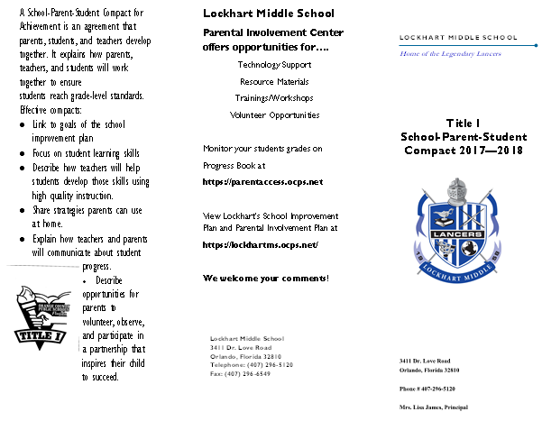  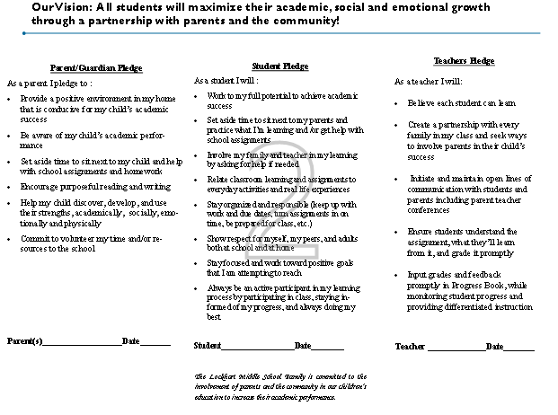

Adoption
The Parent and Family Engagement Policy has been developed jointly with, and agreed on with, parents of children participating in Title I, Part A programs, as evidenced by the School Compact Evaluation Form
11/13/17
1 school year
This policy was adopted by the school on and will be in effect for the period of.
11/20/17
The school will distribute this policy to all parents of participating Title I, Part A children on or before.

Signature of Authorized Personnel | Tierney Houston
Date | 10/25/17

Provide evidence that this policy has been developed with input from parents based on the review of the previous school year’s Parent and Family Engagement Plan, if applicable. (previously referred to as the Parent Involvement Plan – PIP)
The following documents can be scanned with this document and submitted as evidence:
- Parent surveys of previous year’s events and activities
- Any SAC and/or PTA artifacts with Title I/PFE topics on the agenda
- Parent Feedback Summary of PFEP Evaluation
- Parent and Family Engagement Activities Tracking Form

